Data Visualization Report
Date | 31 January 2026
Team ID | LTVIP2026TMIDS28502
Project Name | Visualizing Housing Market Trends: An Analysis of Sale Prices and Features using Tableau

Title: Data Visualization and Preprocessing Report
Project Name: Visualizing Housing Market Trends: An Analysis of Sale Prices and Features using Tableau
Team ID: LTVIP2026TMIDS28502
Dataset: Transformed_Housing_Data2.csv
Tool Used: Tableau Desktop
1. Preprocessing Steps
Data preprocessing is an important step to ensure that the dataset is clean, structured, and ready for visualization and analysis.
1.1 Data Collection
The housing dataset named Transformed_Housing_Data2.csv was collected and stored locally. This dataset contains information such as sale price, house age, renovation status, basement area, bedrooms, bathrooms, and floors.
1.2 Data Connectivity
The dataset was connected to Tableau Desktop using the Text File connection option. Tableau successfully loaded the dataset and displayed all fields for analysis.
1.3 Data Cleaning
The following cleaning steps were performed:
- Verified dataset for missing or null values
- Ensured numeric columns such as Sale Price and Basement Area were correctly identified as measures
- Ensured categorical fields such as Renovation Status were correctly identified as dimensions
- Verified data consistency across all records
1.4 Data Classification
Dimensions identified:
- Renovation Status
- Bedrooms
- Bathrooms
- Floors
Measures identified:
- Sale Price
- Basement Area
- House Age
1.5 Data Validation
The dataset was validated by previewing records in Tableau to ensure correctness and completeness.
Outcome:
The dataset was successfully prepared for visualization.

2. Business Questions with Visualizations
The following business questions were defined and answered using Tableau visualizations.

Business Question 1: What is the total number of housing records?
Visualization Used: KPI Indicator
Fields Used: COUNT(Number of Records)
Purpose:
To understand the total number of houses available in the dataset.
Insight:
This KPI provides an overview of the dataset size and scope.
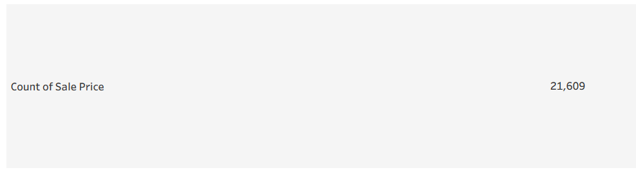
Business Question 2: What is the average sale price of houses?
Visualization Used: KPI Indicator
Fields Used: AVG(Sale Price)
Purpose:
To understand the average housing price.
Insight:
Helps identify overall market pricing level.
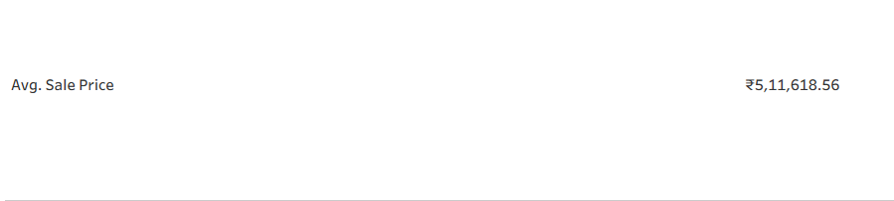
Business Question 3: How does renovation affect house sale prices?
Visualization Used: Bar Chart
Fields Used:
- Columns: Years Since Renovation
- Rows: SUM(Sale Price)
Purpose:
To analyze the impact of renovation on housing price.
Insight:
Recently renovated houses show different pricing trends.
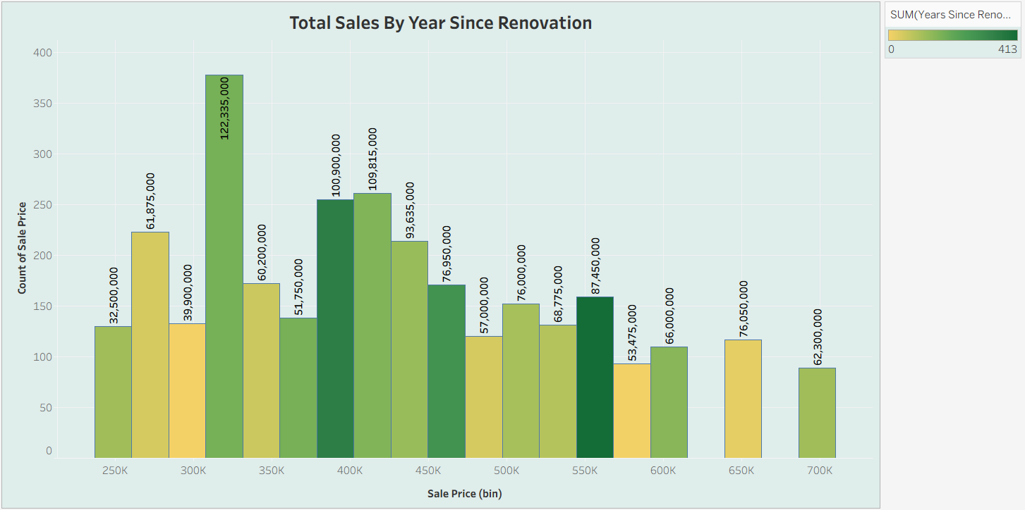
Business Question 4: What is the distribution of house age based on renovation status?
Visualization Used: Pie Chart
Fields Used:
- Color: Renovation Status
- Angle: Number of Records
Purpose:
To analyze age distribution and renovation relationship.
Insight:
Shows proportion of renovated vs non-renovated houses.
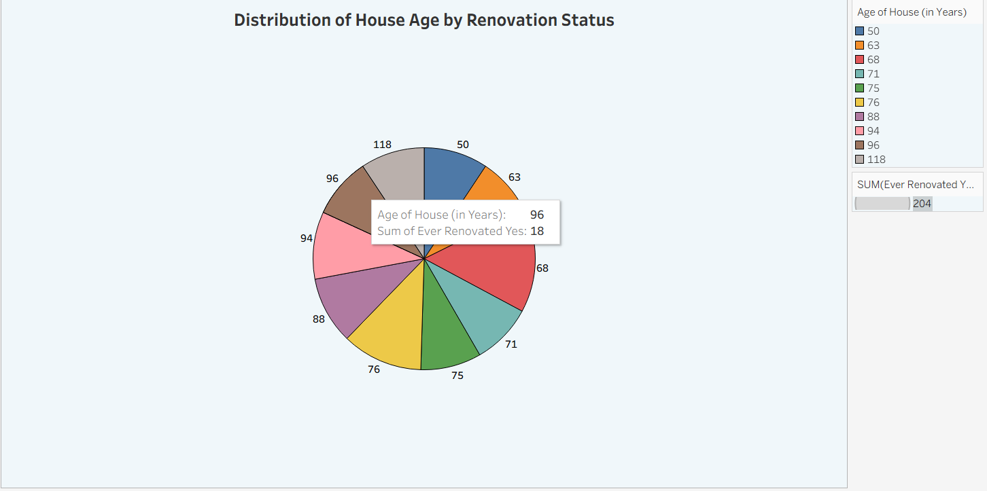
Business Question 5: How are housing features distributed based on age?
Visualization Used: Bar Chart
Fields Used:
- House Age
- Bedrooms
- Bathrooms
- Floors
Purpose:
To analyze structural characteristics of houses.
Insight:
Shows housing design patterns across different age groups.
